

**ICT Upskilling Programmer**

Full Stack Development PHP

By: Ghada Mohammad

This project was submitted to complete the program requirements for the ICT Upskilling Program of Full Stack Development PHP branch at Al Hussein Technical University.

**Table of Contents**

|  |
| --- |
| **Topic Page** |
| **Index of Contents ............................................................................ 2** |
| **Chapter One: Introduction .............................................................. 4** |
| **1.1 Introduction to the project ........................................................ 5** |
| **1.2 Project Objectives ..................................................................... 5** |
| **1.3 Definition of beneficiaries ......................................................... 5** |
| **Chapter Two: Analysis of the System ............................................... 6** |
| **2.1 System Analysis ......................................................................... 7** |
| **2.2 System Life Cycle (SDLC) ............................................................. 7** |
| **2.3 Content Analysis ........................................................................ 7** |
| **2.4 Timeline ..................................................................................... 8** |
| **Chapter Three: System Design .......................................................... 10** |
| **3.1 System Design ............................................................................ 11** |
| **3.2 Entity Relation Diagram (ERD) .................................................... 13** |
| **Chapter Four: Implementation and Testing ...................................... 14** |
| **4.1 Implementation Phase ............................................................... 15** |
| **4.2 Testing Phase ............................................................................. 15** |
| **Chapter Five: User Interface ............................................................. 16** |
| **References........................................................................................ 18** |

**List of shapes**

|  |
| --- |
| **Page Shape** |
| **SDLC .................................................................................................... 7** |
| **Gant Chart .......................................................................................... 10** |
| **ERD...................................................................................................... 13** |
| **The main page of the site .................................................................... 17** |

**List of tables**

|  |
| --- |
| **Table Page** |
| **Timeline ........................................................................................... 9** |

**Chapter One**

Introduction

* 1. **Introduction to the project:**

Wateen bakery project is a point of sale, but the difference is that it is a group of sales points that are summarized in one point where any bakery that has been agreed with can display its products on this site, where it reduces to Wateen bakery a lot of things from the inputs that the bakery needs to make its products and benefit Others from bakeries and people displaying their products.

* 1. **Project Objectives:**

Helping many bakeries and individual stakeholders who have home projects by displaying their products without the need for a place to store them or the need for a building to display their products in it.

**1.3 Introducing the beneficiaries:**

Owner of the project

bakery owners

Individual stakeholders who have home projects

**Chapter Two**

System Analysis

* 1. **System Lifecycle (SDLC):**

The sequence in the stages of construction and development of the system is carried out according to the following scheme:

**Figure 1: System Lifecycle**

* Start with the project and planning: In this section we determine the feasibility of the project, define the project, define its scope, and discuss it with our supervisors to make sure that we choose a good idea to work on.
* Project Analysis: At this stage, we will understand the needs and requirements of the system, and then we will structure these requirements. We mean to provide a description of the activities and processes of the system, we also conduct a full feasibility study on the entire project, and then determine the functions of the system.
* Project Design: The main phase activities are to define database relationships, transfer these relationships to an ER schema that shows all the overall system relationships, and then convert the ER schema into actual tables; then we will design system models and reports.
* Implementation: This phase includes programming, installation and completion of programming for the system. Then we begin to implement the design of the system and link it to its functions with its design.
* Testing: This system will be tested with real data to verify each function and how it works as a live online test during this phase.
* Maintenance: This is the final stage of the SDLC to check the information system if it is systematically repaired and improved.
  1. **Timeline:**

**Table 1 : Timeline**

|  |  |  |  |  |
| --- | --- | --- | --- | --- |
| **Task** | **Description** | **Start time** | **End Time** | **Duration** |
| T1 | Information Gathering | 03/08/22 | 05/08/22 | 3 Days |
| T2 | Planning | 05/08/22 | 08/08/22 | 4 Days |
| T3 | Analysis | 08/08/22 | 13/08/22 | 6 Days |
| T4 | Design | 13/08/22 | 22/08/22 | 10 Days |
| T5 | Development & Implementation | 22/08/22 | 04/09/22 | 14 Days |
| T6 | Testing | 04/09/22 | 05/09/22 | 2 Days |
| T7 | Documentation | 03/08/22 | 05/09/22 | 35 Days |
| T8 | Submission | 06/09/22 | 06/09/22 | 1 Day |

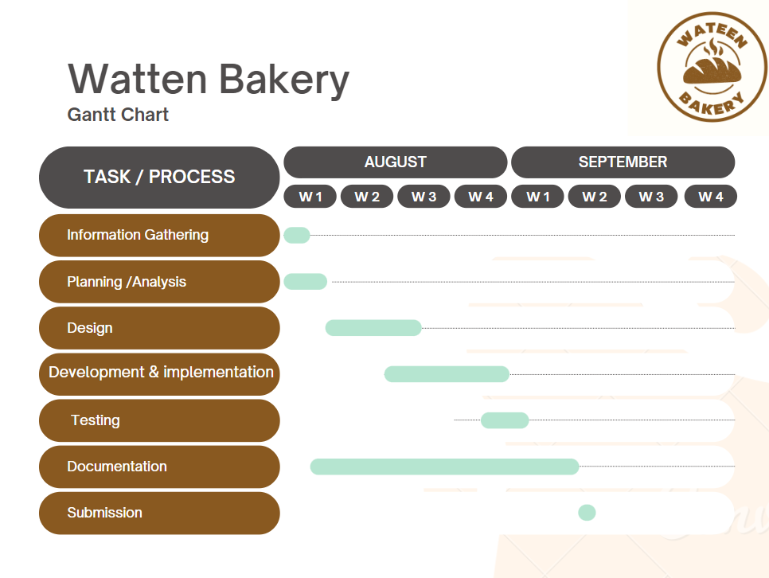

**Figure 2: Gant Chart**

**Chapter Three**

System Design

* 1. **System Design:**

The design phase is the most important stage in the project after the analysis stage, through which the optimal solutions are sought to build the system and therefore need creative skills from the team and carefully studied plans.

This stage implicitly depends on the stage of analysis, if the analysis process is done correctly with the determination of the requirements of the system and its mechanism of work, then several designs will be reached that differ formally but work for the same requirements and objectives, and here comes the choice of the most appropriate and best form among them.

* 1. **Entity Relation Diagram (ERD):**

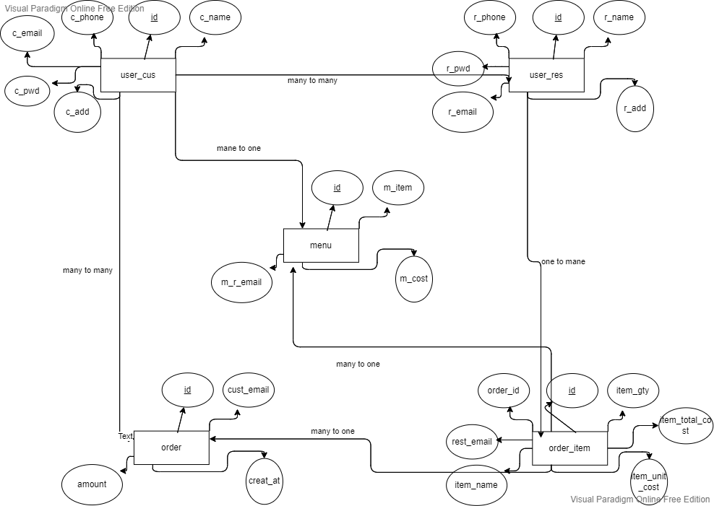

**Figure 4: ERD**

**Chapter IV**

Implementation and testing

* 1. **Implementation Phase:**

At this stage, it is recognized how the system works, how to determine the system administrator and determine the user's permissions in the mechanism of using the site.

System Administrator: is the person responsible for managing the site by identifying the overall specialties of the site

User: A person who will use the Site in both ways, either requesting or providing the Service.

* 1. **Testing Phase:**

At this stage, errors are discovered after the system experience, corrected and made sure that the system has completed as required, in terms of achieving the objectives and importance required of it, and this stage is considered the last stage of building the system where the system is checked by making sure that each screen works individually and then linking the screens with each other and making sure the mechanism of work of the screens correctly, and most parts of the system were accomplished by the team meeting to make sure that the system works well And without mistakes.

**Chapter Five**

User Interface

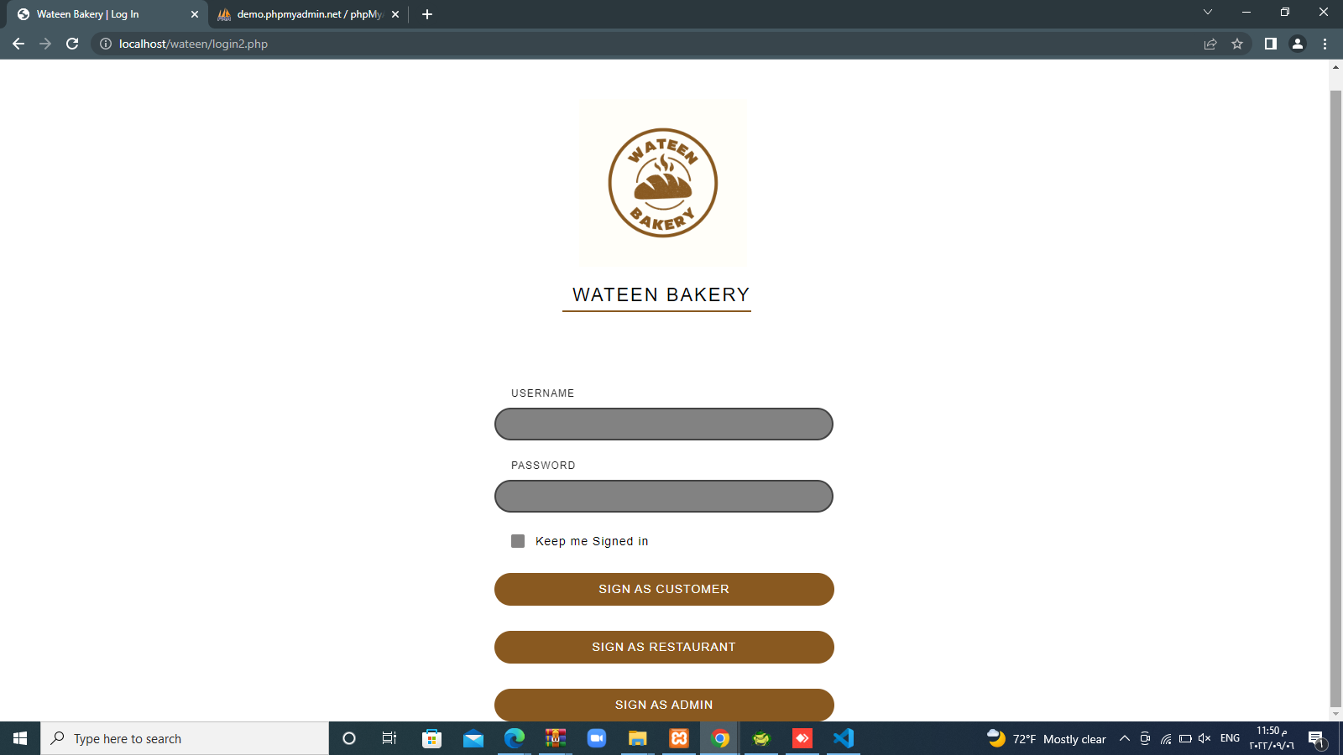

**Figure 5: The main interface of the site**

**References**

1. https://www.w3schools.com
2. https://getbootstrap.com
3. https://notepad++.com
4. Systems Analysis and Design (8th Edition) by Kendall Kendall